جامعة المنوفية
كلية الحاسبات والمعلومات
2021-2022
Menofyia University
System Analysis & design Project
second year
2021-2022

Hotel

Planning

Project Identification
Project Name:
Registration of hotel’s guests

Current Problem:
The Hotel needs a system to insert, update and delete the information of its guests.

System Request

System Request—Hotel
Project Sponsor: | Mr. Mohamed Saad
Business Need: | 1. software to save all hotel guests, their room numbers and their accounts.  2. apply rules.
Business Requirements: | 1. Provide on-line access.  2. Capture guests’ information.  3. Produce management reports.  4. Broadcast final report.  5. Can work offline.  6. Speed up customer service.  7. Manage guests’ profile.  8. More usable.  9. More secure.
Business Value: | 1. Reduce 10% of total cost.  2. Reduce number of employees by 25%.
Special Issues or Constraints: | 1. Deadline 20/10/2022.  2. Network.  3. More security.

Feasibility Analysis
Technical Feasibility
- Cloud team is professional team
- Business team is good and more personal
- Security team need to update used technology
- Backend needs to switch from django python to node.js.

Economic Feasibility
- Cost of the cloud server is 2000$ per year.
- Cost of training the hotel team is 200$.
- Cost of node.js course is 1000$.
- Profit of hotel increase by 10000$ per month.

Organizational Feasibility
- Online authorization is more reliable.
- Using email to receive reports.

Schedule Feasibility
1. The first release will be finished on 1/1/2022
Time Estimation

 | Planning | Analysis | Design | Implementation
Standard percentages | 15% | 20% | 35% | 30%
Estimated time based on planning time | 1.5 months | 2 months | 3.5 months | 3 months

Tasks Identification

Perform feasibility analysis | Name of Task
1/9/2021 | Start Date
4/9/2021 | End Date
Mohamed Hassan | Person assigned to task
High | Priority
Microsoft Word | Resources Needed
40 hours | Estimated Time
36 hours | Actual Time

Methodology | Name of Task
5/9/2021 | Start Date
7/9/2021 | End Date
Mohamed Badr | Person assigned to task
high | Priority
Microsoft Word | Resources Needed
16 hours | Estimated Time
13 hours | Actual Time

Task Identification | Name of Task
8/9/2021 | Start Date
10/9/2021 | End Date
Mohamed Mosaad | Person assigned to task
High | Priority
Microsoft Word | Resources Needed
20 hours | Estimated Time
22 hours | Actual Time

Time estimation | Name of Task
8/9/2021 | Start Date
11/9/2021 | End Date
Mohamed Badr | Person assigned to task
Low | Priority
Microsoft Excel | Resources Needed
17 Hours | Estimated Time
15 hours | Actual Time

Perform GUI | Name of Task
1/10/2021 | Start Date
1/11/2021 | End Date
Mohamed Hassan | Person assigned to task
Medium | Priority
V S Code | Resources Needed
25 days | Estimated Time
26 days | Actual Time

Pert Chart | Name of Task
8/10/2021 | Start Date
13/10/2021 | End Date
Mohamed Abd Alaziz | Person assigned to task
medium | Priority
Microsoft Excel | Resources Needed
20 hours | Estimated Time
17 hours | Actual Time

Gnatt Chart | Name of Task
13/10/2021 | Start Date
15/10/2021 | End Date
Nada El Said | Person assigned to task
medium | Priority
Microsoft Excel | Resources Needed
30 hours | Estimated Time
29 hours | Actual Time

Pert Chart (MS-Project)

Task Id | Task Name |  | Content | Predecessors | duration
A | System Request | A1  A2  A3  A4 | Business need  Business requirement  Business value  Special issues | __ | 3
B | Feasibility study | B1  B2  B3  B4 | Technical  Economic  Operational  Schedule | __ | 3
C | Methodology | __ | Agile(way) | B | 2
D | Task Identification | D1  D2  D3  D4  D5 | Name of Task  Person assigned  Priority  Estimated time  Actual time | C | 2
E | Time Estimation | __ |  | A,C | 3
F | Pert Chart | __ |  | C | 5
G | Gnatt Chart | __ |  | D,E,F | 2

A

E
1
4
5
G
7
C
B
D
F

F
C
6
3
2

Gantt chart (MS-Project)

 |  |  | Start | End
A | System Request | __ | 28/8/2021 | 31/8/2021
B | Feasibility study | __ | 1/9/2021 | 4/9/2021
C | Methodology | B | 5/9/2021 | 7/9/2021
D | Task Identification | C | 8/9/2021 | 10/9/2021
E | Time Estimation | A,C | 8/9/2021 | 11/9/2021
F | Pert Chart | C | 8/9/2021 | 13/9/2021
G | Gnatt Chart | D,E,F | 13/9/2021 | 15/9/2021

Interview Reports
Interview Report
Person Interviewed: Mr. Mohamed Saad, Senior, Human Resources.
Interviewer: Mohamed Mosaad.
Purpose of Interview:
- This interview aimed to determine the problems encountered by the employees of hotels.
More specifically, this study obtained the profile of the respondents in terms of gender,
age, civil status, educational attainment, position, and years of service; determined the common problems encountered by the hotel employees with the management and with the customers; sought the significant relationship between the demographic profile of the respondents, and problems encountered with the management and with the customers; established a plan to solve the problems encountered by the hotel employees.
Summary of Interview:
1-Problems Encountered by Hotel Employees with the Management:
- The respondents sometimes encountered economic problems. The problems that the respondents have sometimes encountered and have the highest rank are the management does not have complete equipment and facilities.
- It is closely followed by not giving incentives for extra work and benefits like 13th month pay and interpreted as “sometimes”.
- Last in rank is that the respondents never encountered that management are delayed in paying salaries and overtime.
2-Problems encountered by Hotel Employees with the Customers:
- The employee sometimes encounter customers who are too demanding, too messy , too impatient and too bossy.
- However, most of the respondents never encountered customers who discriminate the employees.
- This implies that even the employees encountered problems with the customers; the employees did not recognize it as a problem because it is just part of their job.
Open Items:
- Develop a plan to solve the problems faced by the hotel employees.
- Solve economic problems and provide complete equipment and facilities.
- Pay salaries on time and overtime incentives.
- Establish rules to eliminate customer chao.

Data Flow Diagram - Context Diagram

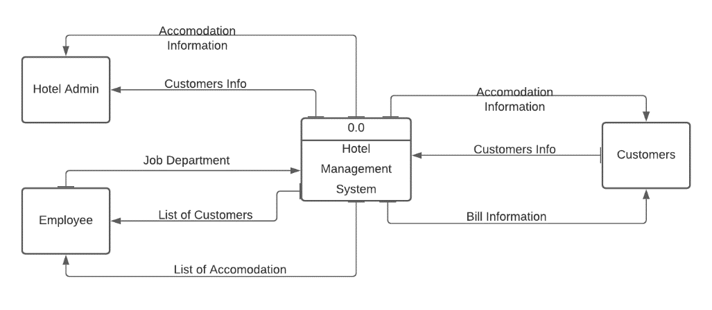

Data Flow Diagram – Level/Diagram 0

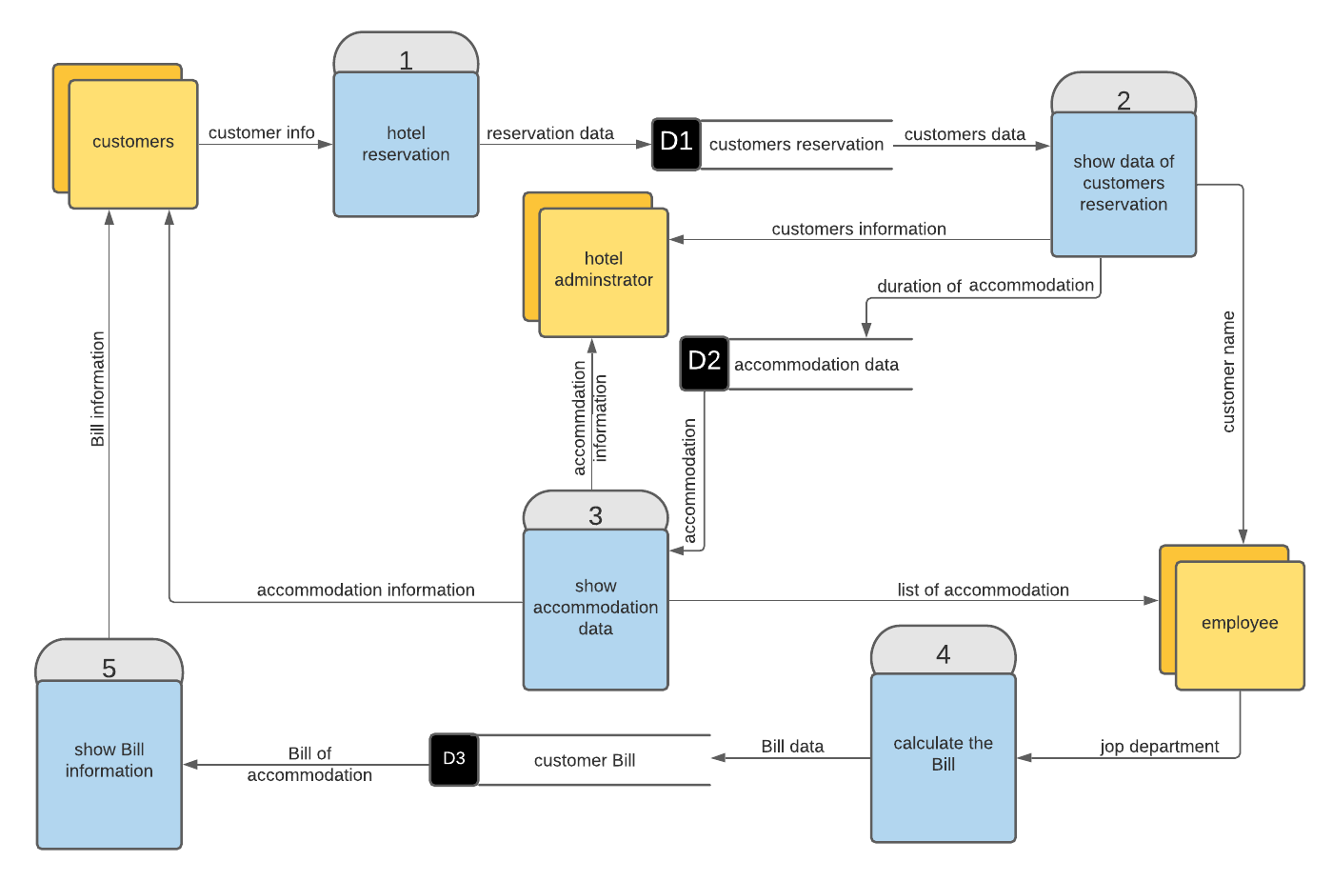

Data Flow Diagram – Level 1

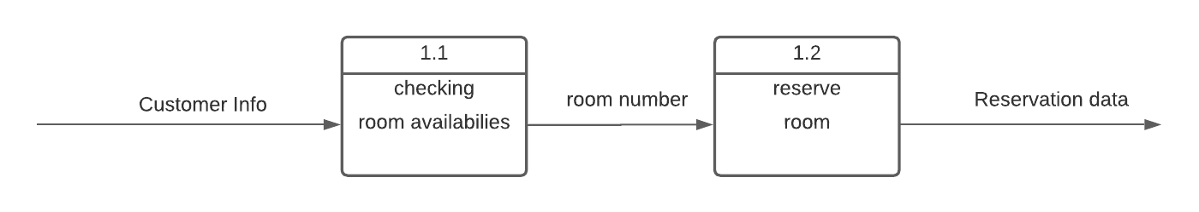

Normalization
Hotel-  iD | Customer-  iD | employee | name | phone | address | email | Qualification
1 | Cus02 | 040 | helton | 056789 | Caro | Helton567@gmail.com | Simple booking  Fast, friendly, first contact
3 | Cus02 | 048 | Du and ku | 034982 | Tanta | Du528@gmail.com | A variety of excellent food and  drink
5 | Cus03 | 052 | Guest  house | 076235 | Alex | Guast948@gmail.com | One site service that delight
9 | Cus04 | 060 | milia | 098421 | Giza | Milia625@gmail.com | Agentively, Cheerful, helpful  Knowledgeable start
11 | Cus05 | 080 | mariote | 042001 | Luxor | Mariote325@gmail.com | A social lobby Referral service  24 fitness centers
15 | Cus06 | 090 | San-susi | 024200 | Aswan | Sans123@gmail.com | Quick resolution of problems

Hotel-id | Customer-id | Name
1 | Cus02 | Helton
3 | Cus02 | Du and ku
5 | Cus03 | Guest house
9 | Cus04 | Milia
11 | Cus05 | Mariote
15 | Cus06 | Sas-susi

Customer-id | Name | Phone | Address | Email
Cus02 | Helton | 05678 | Caro | Helton567@gmail.com
Cus02 | Du and ku | 034982 | Tanta | Du528@gmail.com
Cus03 | Guest house | 076235 | Alex | Guast948@gmail.com
Cus04 | Milia | 0984211 | Giza | Milia625@gmail.com
Cus05 | Mariote | 042001 | Luxor | Mariote325@gmail.com
Cus06 | Sas-susi | 024200 | Aswan | Sans123@gmail.com

5 | Guast548@gmail.com | Guashouse | Alix | One site service  that delight
9 | Milia625@gmail.com | Milia | Giza | A genuinely cheerful helpful  knowledge able start
11 | Mariote325@gmail.com | Mariote | Luxor | Asocial lobby Referral service  24 fitness centers
15 | Sans123@gmail.com | Sas-sus | Aswan | Quick resolution of  problems

Hottel-id | Employee-id | Name | Address | Qualifications
1 | Hattal567@gmail.com | Hattal | Caro | Simple Booking  , fast friendly first contact
3 | Du528@gmail.com | Duandku | Tanta | A variety of Excellent food and  Drink

Entity Relationship Diagram (ERD)
